Pregnant?

Did you know that you can self-refer to Macclesfield Maternity Unit quickly and easily online?
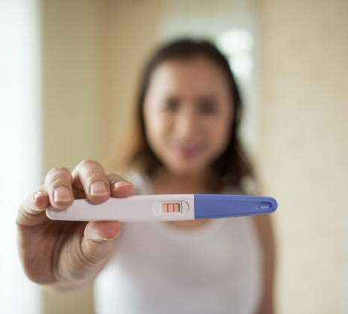

Visit the East Cheshire NHS website and select Maternity to complete your self-referral form.

